

**Octopus**

**Pangsha, P.S: Biman Bondor, Upazila: Babugonj, Barisal, Bangladesh.**

**[Type the phone number]**

**[Type the fax number]**

**[Pick the date]**

**Octopus**

Table of Contents

[A Brief History of OCTOPUS 1](#_Toc168499327)

[Product and Services 1](#_Toc168499328)

[ Food and beverage division 1](#_Toc168499329)

[ Culinary 2](#_Toc168499330)

[ Dairy 2](#_Toc168499331)

[ Snacks 2](#_Toc168499332)

[ Confectionery 2](#_Toc168499333)

[Business plan 3](#_Toc168499334)

[Sales and Cost Statistics 5](#_Toc168499335)

[Awards 6](#_Toc168499336)

[Source of Competitive Advantage of Octopus foods 7](#_Toc168499338)

[Corporate Values 7](#_Toc168499339)

# A Brief History of OCTOPUS

Octopus helps its customers feel like their best selves by providing affordable and hygienic food and beverage products. This new business is a sole proprietorship, owned and operated by Md Rassel Hossain Rocky, in Barisal, Bangladesh.

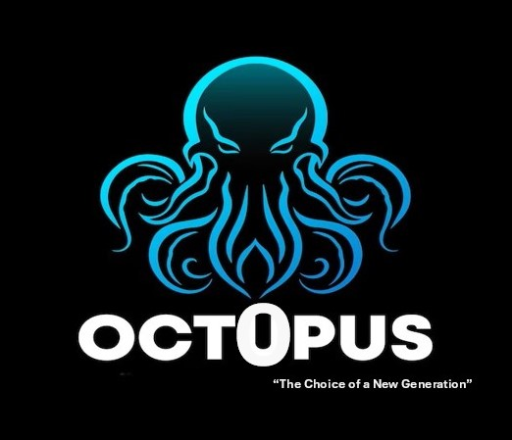Its main objective is to help reduce poverty and boost the agricultural sector in Bangladesh, with a focus on creating job opportunities and promoting dignity and self-respect among its peers.

Octopus has been working towards this goal since 2022, particularly in developing the agricultural and rural areas of the country.

Now that the business has achieved local success, including a storefront in downtown Barisal, Octopus is looking to expand. The company hopes to grow its customer base throughout the southeastern Bangladesh by the end of next year.

Octopus currently provides direct employment to around 2000 individuals and indirectly supports 100000.

All the products are produced as per international standards maintaining highest level of quality at every stages of its production process.

So based those discussion Octopus is started from corporate level which refers –

* Mission: The mission of Octopus foods is to generate employment and earn dignity and self-respect for our competitors through profitable enterprise.
* Vision: The vision of the company is to create a wonderful brand image throughout the world and improving livelihood.
* Objectives: Innovate new products, try to fulfill public demand, give full consumer satisfaction, distribute product all over the country, set a reasonable price and so on.
* Goal: Become the No.1 brand all over the country.

# Product and Services

Octopus Group has more than 500 products and 5 Division. Following are some of the major sectors where Octopus has a presence:

* Food and beverage division**:** It offers a wide range of products, including juices, snacks, dairy products, and bakery items. The food and beverage industry is a significant contributor to the workforce in Bangladesh. It has been growing rapidly in recent years. According to the Economic Census of 2016, there are about 246 medium-sized food and beverage companies in the country, providing employment opportunities to 19% of the manufacturing workforce and 8% of the total [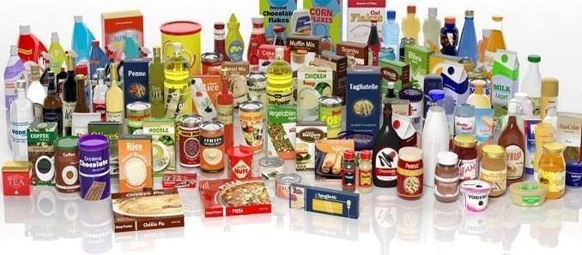](https://pritiresearch.com.bd/food-products-and-beverage-industry-of-bangladesh/)workforce. Between 2014 and 2017, the industry grew at an average rate of 7.7% per year. Moreover, in 2017, Bangladesh exported more than $700 million worth of processed foods and beverages, with shrimp and fish products accounting for over 60% of the total.
* 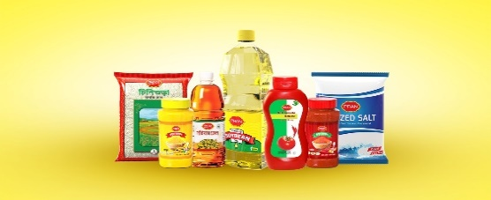Culinary**:** This category includes food products that are typically used in cooking or as ingredients in recipes. Examples of culinary products offered by Octopus Biscuit & Bakery might include cooking oils, spices, and condiments.
* [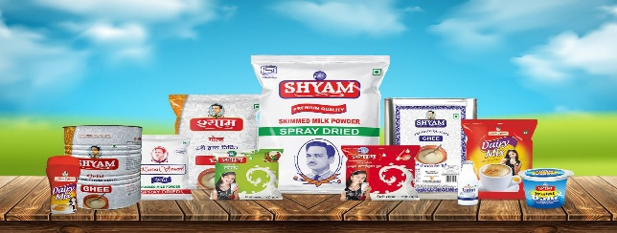](https://shyamdairy.com/)Dairy**:** This category includes products made from milk or dairy products, such as milk, cheese, and yogurt. Octopus Biscuit & Bakery might offer dairy products such as milk, butter, or cheese.
* 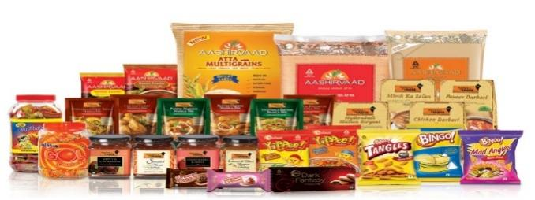Snacks**:** Snacks are food products that are typically consumed between meals or as quick snacks on the go. Examples of snack products offered by Octopus Biscuit & Bakery might include potato chips, nuts, or granola bars.
* Confectionery: Confectionery refers to sweet food products, such as candy, chocolate, and desserts. Octopus Biscuit & Bakery might offer confectionery products such as cookies, cakes, or chocolates.

# Business plan

In a field as crowded with competitors as the food and beverage space, a detailed [market analysis](https://www.bplans.com/business-planning/how-to-write/market-analysis/) is essential. Market research questions specific to a food and beverage business includes:

* Business location and characteristics
* Area income
* Local food and beverage preferences
* Existing food and beverage options

With so many options for consumers in the food and beverage space, we rely on multiple marketing channels, including:

* Advertising on websites, television, and in relevant publications.
* Content marketing — [developing an engaging website](https://www.bplans.com/start-a-business/marketing/online-presence/create-coming-soon-website/) and [writing blog content](https://www.bplans.com/start-a-business/marketing/channels/start-a-blog/) that’s search engine optimized to drive traffic to our site.
* Engaging with our customers on social media.
* Offering discounts and customer loyalty programs.
* Appearing at food and beverage industry trade shows and community events.

The [operations strategy](https://www.bplans.com/business-planning/how-to-write/operations/) is the most detailed section of our business plan. This section describes how we will run our business day to day. It describes the following:

* Physical space: In terms of the development of the target customer group, the company [management of Octopus Food and Beverage](https://peachyessay.com/sample-essay/business/food-and-beverage-management/" \t "_blank) Private Limited target people of all the demographic background. The quality and differentiation factor regarded as unique selling proposition of the company. In terms of pricing and proposition strategy, the [company management](https://peachyessay.com/sample-essay/business/food-and-beverage-management/" \t "_blank) of Octopus Food and Beverage Private Limited sell the products at [economic price level to gain competitive](https://peachyessay.com/sample-essay/the-comparison-of-economic-competitiveness-and-development-of-the-us-saudi-arabia/" \t "_blank) advantages. In terms of distribution plan, the company develop an open-ended decentralized distribution network.
* Supply chain: We have the suppliers and partners that get our product to customers. These are our supply chain partners. We always maintain good relationships with them.
* Production processes: We used advanced machinery to make our product, and use organic and fresh materials and equipment to produce our goods. We also uncover ways to produce them more quickly, or at a lesser cost.
* Logistics: We prudently handle matters of efficiency like order fulfillment, storage, shipping, and returns, as well as customer satisfaction.
* Employees: We have experienced staff, and we also focus on staffing needs and training. They maintain the management structure of our business. This helps ensure that important tasks to monitor are being done and that workers are being supervised.
* Technology: Investments in payment processing systems, inventory management software, and other tools that support sales or operations in our business are described in the company strategies.

**6 Steps to Start a Food and Beverage Business**

**Farm, Grower, Producer**

Food Manufacturer, Bulk Shipper or Processor

Retail Distributer

Food service Distributer

International Shippers

Grocery Stores

Restaurants

International Markets

Customers and Consumers

Fig: Flow chart of food industry supply chain

# Sales and Cost Statistics

|  |  |  |  |
| --- | --- | --- | --- |
| Yearly Report - 2023 | | | |
| Month | Expenses | Sales | Profit |
| January | 9288500 | 8750000 | -538500 |
| February | 9744300 | 9920000 | 175700 |
| March | 8904700 | 10000000 | 1095300 |
| April | 7345200 | 7957400 | 612200 |
| May | 8987000 | 9876500 | 889500 |
| June | 5215400 | 5164500 | -50900 |
| July | 9976500 | 11543600 | 1567100 |
| August | 7976700 | 8087900 | 111200 |
| September | 9879000 | 9969800 | 90800 |
| October | 6234800 | 7024000 | 789200 |
| November | 4534800 | 4809300 | 274500 |
| December | 8348700 | 8834800 | 486100 |

|  |  |  |  |  |
| --- | --- | --- | --- | --- |
| Monthly Report - 2024 | | | | |
| Month | Expenses | Sales | Retail Profit | Profit/ Loss |
| January | 7854500 | 8750000 | 895500 | **Profit** |
| February | 9998300 | 9920000 | -78300 | **Loss** |
| March | 8985700 | 10000000 | 1014300 | **Profit** |
| April | 8876550 | 8756000 | -120550 | **Loss** |
| May | 9988300 | 11200000 | 1211700 | **Profit** |

# Awards

# Awards

* Top VAT payers Awards from the [National Board of Revenue](https://en.wikipedia.org/wiki/National_Board_of_Revenue" \o "National Board of Revenue) for being top [VAT](https://en.wikipedia.org/wiki/Value-added_tax" \o "Value-added tax) payer in different financial year.
* National Productivity Award by [National Productivity Organization](http://www.npo.gov.bd/).
* Best Employer Brand Award.
* National Export Trophies.

# Source of Competitive Advantage of Octopus foods

Competitive advantage refers product’s position. It means the place the product occupies in consumers’ minds relative to competing products. Marketers must plan positions to give products the greatest advantage and develop marketing mixes to create planned positions.

The competitive advantage of Octopus foods is, it has a lot of product items and those products have some flavors. Sometimes Octopus produce traditional foods which is also an advantage.

# Corporate Values

We take pride in our hard work and continuous efforts that made us become OCTOPUS— a name, a face, an organization of marvelous performance, leaving positive marks on the native, as well as on global grounds in the course.

OCTOPUS is a corporation that firmly believes in providing equal opportunity for everyone, and our talent management has ensured the perfect atmosphere for the workforce, enabling them to work together as a team. Besides, we take every complaint and suggestion with the utmost sincerity to improve the workplace for all. Professional integrity is highly maintained and is, in fact, the core of our work policy.

Above all, as a company, OCTOPUS truly believes in dedicating itself for the benefit of its stakeholders and society at large. We practice the values we uphold and therefore, through our actions, we help the economic progress, and with its growth, the people living inside the economy also advance.

****

**Corporate Headquarters:**

Octopus Center

3rd Baitul Aman Road, Rupatoli,

Barisal - 8200, Bangladesh.

Phone: +8801315-485517

Fax: +88-02-8867435

**Factory:** Pangsha, P.S: Biman Bondor,

Upazila: Babugonj, Barisal, Bangladesh.

**Email:** [info@octopusconsumer.com](mailto:info@octopusconsumer.com)

**Social:**